## School of Computer Science & Statistics Research Ethics Application

### CHECKLIST

**The following documents are required with each application:**

|  |  |  |
| --- | --- | --- |
| **1.** | * SCSS Ethical **Application Form** |  |
| **2.** | * **Participant’s Information Sheet** must include the following:  Declarations from Part A of the application form;  * 1. Details provided to participants about how they were selected to participate;   2. Declaration of all conflicts of interest. |  |
| **3.** | * **Participant’s Consent Form** must include the following:  Declarations from Part A of the application form; **b)** Researchers contact details provided for counter-signature (your participant will keep one copy of the signed consent form and return a copy to you). |  |
| **4.** | * **Research Project Proposal** must include the following:  You must inform the Ethics Committee **who** your intended participants are i.e. are they your work colleagues, class mates etc.   1. How will you recruit the participants i.e. **how** do you intend asking people to take part in your research? For example, will you stand on Pearse Street asking passers-by? 2. If your participants are under the age of 18, you must seek both parental/guardian AND child consent. |  |
| **5.** | * Intended **questionnaire**/survey/interview protocol/screen shots/representative materials (as appropriate) |  |
| **6.** | * **URL** to intended on-line survey (as appropriate) |  |

**Notes on Conflict of Interest**

1. If your intended participants are work colleagues, you must declare a potential conflict of interest: you are taking advantage of your existing relationships in order to make progress in

your research. It is best to acknowledge this in your invitation to participants.

1. If your research is also intended to direct commercial or other exploitation, this must be declared. For example, *“Please be advised that this research is being conducted by an employee of the company that supplies the product or service which form an object of study within the research.”*

### Notes for questionnaires and interviews

1. If your questionnaire is **paper based**, you must have the following **opt-out** clause on the top of each page of the questionnaire: *“Each question is optional. Feel free to omit a response to any*

*question; however the researcher would be grateful if all questions are responded to.”*

#### If you questionnaire is **on-line**, the first page of your questionnaire must repeat the content of the information sheet. This must be followed by the consent form. If the participant does not agree to the consent, they must automatically be exited from the questionnaire.

1. Each question must be **optional**.
2. The participant must have the option to ‘**not submit, exit without submitting’** at the final

#### submission point on your questionnaire.

*5.* If you have open-ended questions on your questionnaire you must warn the participant against naming **third parties**: “*Please do not name third parties in any open text field of the questionnaire. Any such replies will be anonymised.”*

*6.* You must inform your participants regarding **illicit activity**: “*In the extremely unlikely event that illicit activity is reported I will be obliged to report it to appropriate authorities.”*

Ethics Application Guidelines – August 2014

### UNIVERSITY OF DUBLIN, TRINITY COLLEGE

**Faculty of Engineering, Mathematics and Science *School of Computer Science and Statistics* RESEARCH ETHICS PROTOCOL**

##### When is Ethical Approval Needed?

Ethical approval is required before any studies involving human participants can commence. This requirement applies to

studies to be undertaken by staff, postgraduate and undergraduate students. In the case of collaborative projects involving researchers from outside the School, ethical approval obtained from an external research ethics body may suffice –

evidence of same must be submitted to the SCSS Research Ethics Committee prior to the commencement of the study (see procedures below). In the absence of such external approval, approval must be obtained as per this document. Additional ethical approval may be required if the project involves or is funded by an external body, for example, studies under FP7 automatically require such approval.

For the purpose of this document a “study” may be understood to involve a potentially staged series of different experiments to be conducted over a period of time. If substantive changes are made to a study following receipt of ethical approval, this will constitute a new study for which further ethical approval must be obtained.

##### Procedure

Completed application forms together with supporting documentation should be submitted electronically to [research-ethics@scss.tcd.ie](mailto:research-ethics@scss.tcd.ie) To submit, if the proposal is from an undergraduate or postgraduate students, the **completed** application package must be presented to the academic supervisor who will sign after verifying completeness. These signed originals may be scanned and emailed. Please use TCD e-mail addresses only. When your application has been reviewed and approved by the Ethics committee hardcopies of the application form with original signatures should be

submitted to the School of Computer Science & Statistics, Room F37, O’Reilly Institute, Trinity College, Dublin 2.

The Committee will consider each application and normally provide a response within two weeks but not more than one month later. Applications that are considered not to have significant ethical implications may be evaluated by the Committee Chair without reference to the full Committee. Applications will otherwise be considered at a meeting of the SCSS Research Ethics Committee. When approval has been obtained from an external research ethics committee, and School approval is not required, a copy of the external ethical approval must be submitted to the School’s Research Unit, prior to commencement of study, for noting by the SCSS Research Ethics Committee.

Please note that in signing the approval form one is making a commitment to review the provisions of the Data Protection Act, like legislation and College Policy on Good Research Practice. Please ensure that your study conforms to the standards of anonymity preservation and data retention set in those documents. Those provisions suggest a default proscription against making digital or photographic recordings of participants. A study which requires such records must include in the research ethics approval application a justification and documentation of the methods by which the statutory provisions and research practise guidelines will be met.

*Note: These procedures may be amended from time-to-time following recommendation by the SCSS Research Ethics Committee and with the approval of the SCSS Research Committee.*

##### Before seeking ethical approval researchers should:

* identify actual and potential ethical issues that might arise;
* reflect on how these will be addressed; and
* formulate procedures to deal with all such issues.

##### During the research project researchers should:

* implement the ethical procedures;
* obtain continuous feedback from participants about ethical issues;
* periodically review the ethical strategy in the light of feedback received; and
* if required, update their ethical procedures;
* retain copies of consent forms signed by the participants.

##### Composition of the SCSS Research Ethics Committee

The Committee will consist of a Chairperson/Convenor appointed by the Director of Research and two other experts – a member of the School’s academic staff and external advisors. The internal and external members will be selected from a panel approved by the Director of Research from time to time. Members will be selected on a case by case basis by the

Chairperson subject to their availability. Researchers will be precluded from the Committee considering ethical approval for their study.

### School of Computer Science and Statistics Research Ethical Application Form

**Part A**

Project Title: ..The Reporting of Head Trauma in Rugby.....................................................................................

Name of Lead Researcher (student in case of project work): .............................Daniel Owen

Name of Supervisor: .....Mrs. Mary Sharp......................................................................................................

TCD E-mail: …dowen@tcd.ie…………. Contact Tel No.: …0873118524......…..........……

Course Name and Code (if applicable): ……Final Year Business and Computing CS4091……………

Estimated start date of survey/research: ……1st December 2016............................................... .....………………

I confirm that I will (where relevant):

* Familiarize myself with the Data Protection Act and the College Good Research Practice guidelines

[http://www.tcd.ie/info_compliance/dp/legislation.php;](http://www.tcd.ie/info_compliance/dp/legislation.php)

* Tell participants that any recordings, e.g. audio/video/photographs, will not be identifiable unless prior written permission has been given. I will obtain permission for specific reuse (in papers, talks, etc.)
* Provide participants with an information sheet (or web-page for web-based experiments) that describes the main procedures (a copy of the information sheet must be included with this application)
* Obtain informed consent for participation (a copy of the informed consent form must be included with this application)
* Should the research be observational, ask participants for their consent to be observed
* Tell participants that their participation is voluntary
* Tell participants that they may withdraw at any time and for any reason without penalty
* Give participants the option of omitting questions they do not wish to answer if a questionnaire is used
* Tell participants that their data will be treated with full confidentiality and that, if published, it will not be identified as theirs
* On request, debrief participants at the end of their participation (i.e. give them a brief explanation of the study)
* Verify that participants are 18 years or older and competent to supply consent.
* If the study involves participants viewing video displays then I will verify that they understand that if they or anyone in their family has a history of epilepsy then the participant is proceeding at their own risk
* Declare any potential conflict of interest to participants.
* Inform participants that in the extremely unlikely event that illicit activity is reported to me during the study I will be obliged to report it to appropriate authorities.
* Act in accordance with the information provided (i.e. if I tell participants I will not do something, then I will not do it).

Signed: ............Daniel Owen....................... Date: .............17/10/16.............

Lead Researcher/student in case of project work

### Part B

|  |  |  |
| --- | --- | --- |
| ***Please answer the following questions.*** | | ***Yes/No*** |
| Has this research application or any application of a similar nature connected to this research project been  refused ethical approval by another review committee of the College (or at the institutions of any collaborators)? | | No |
| Will your project involve photographing participants or electronic audio or video recordings? | | Yes |
| Will your project deliberately involve misleading participants in any way? | | No |
| Does this study contain commercially sensitive material? | | No |
| Is there a risk of participants experiencing either physical or psychological distress or discomfort? If yes,  give details on a separate sheet and state what you will tell them to do if they should experience any such  problems (e.g. who they can contact for help). | | No |
| Does your study involve any of the following? | Children (under 18 years of age) | No |
| People with intellectual or  communication difficulties | No |

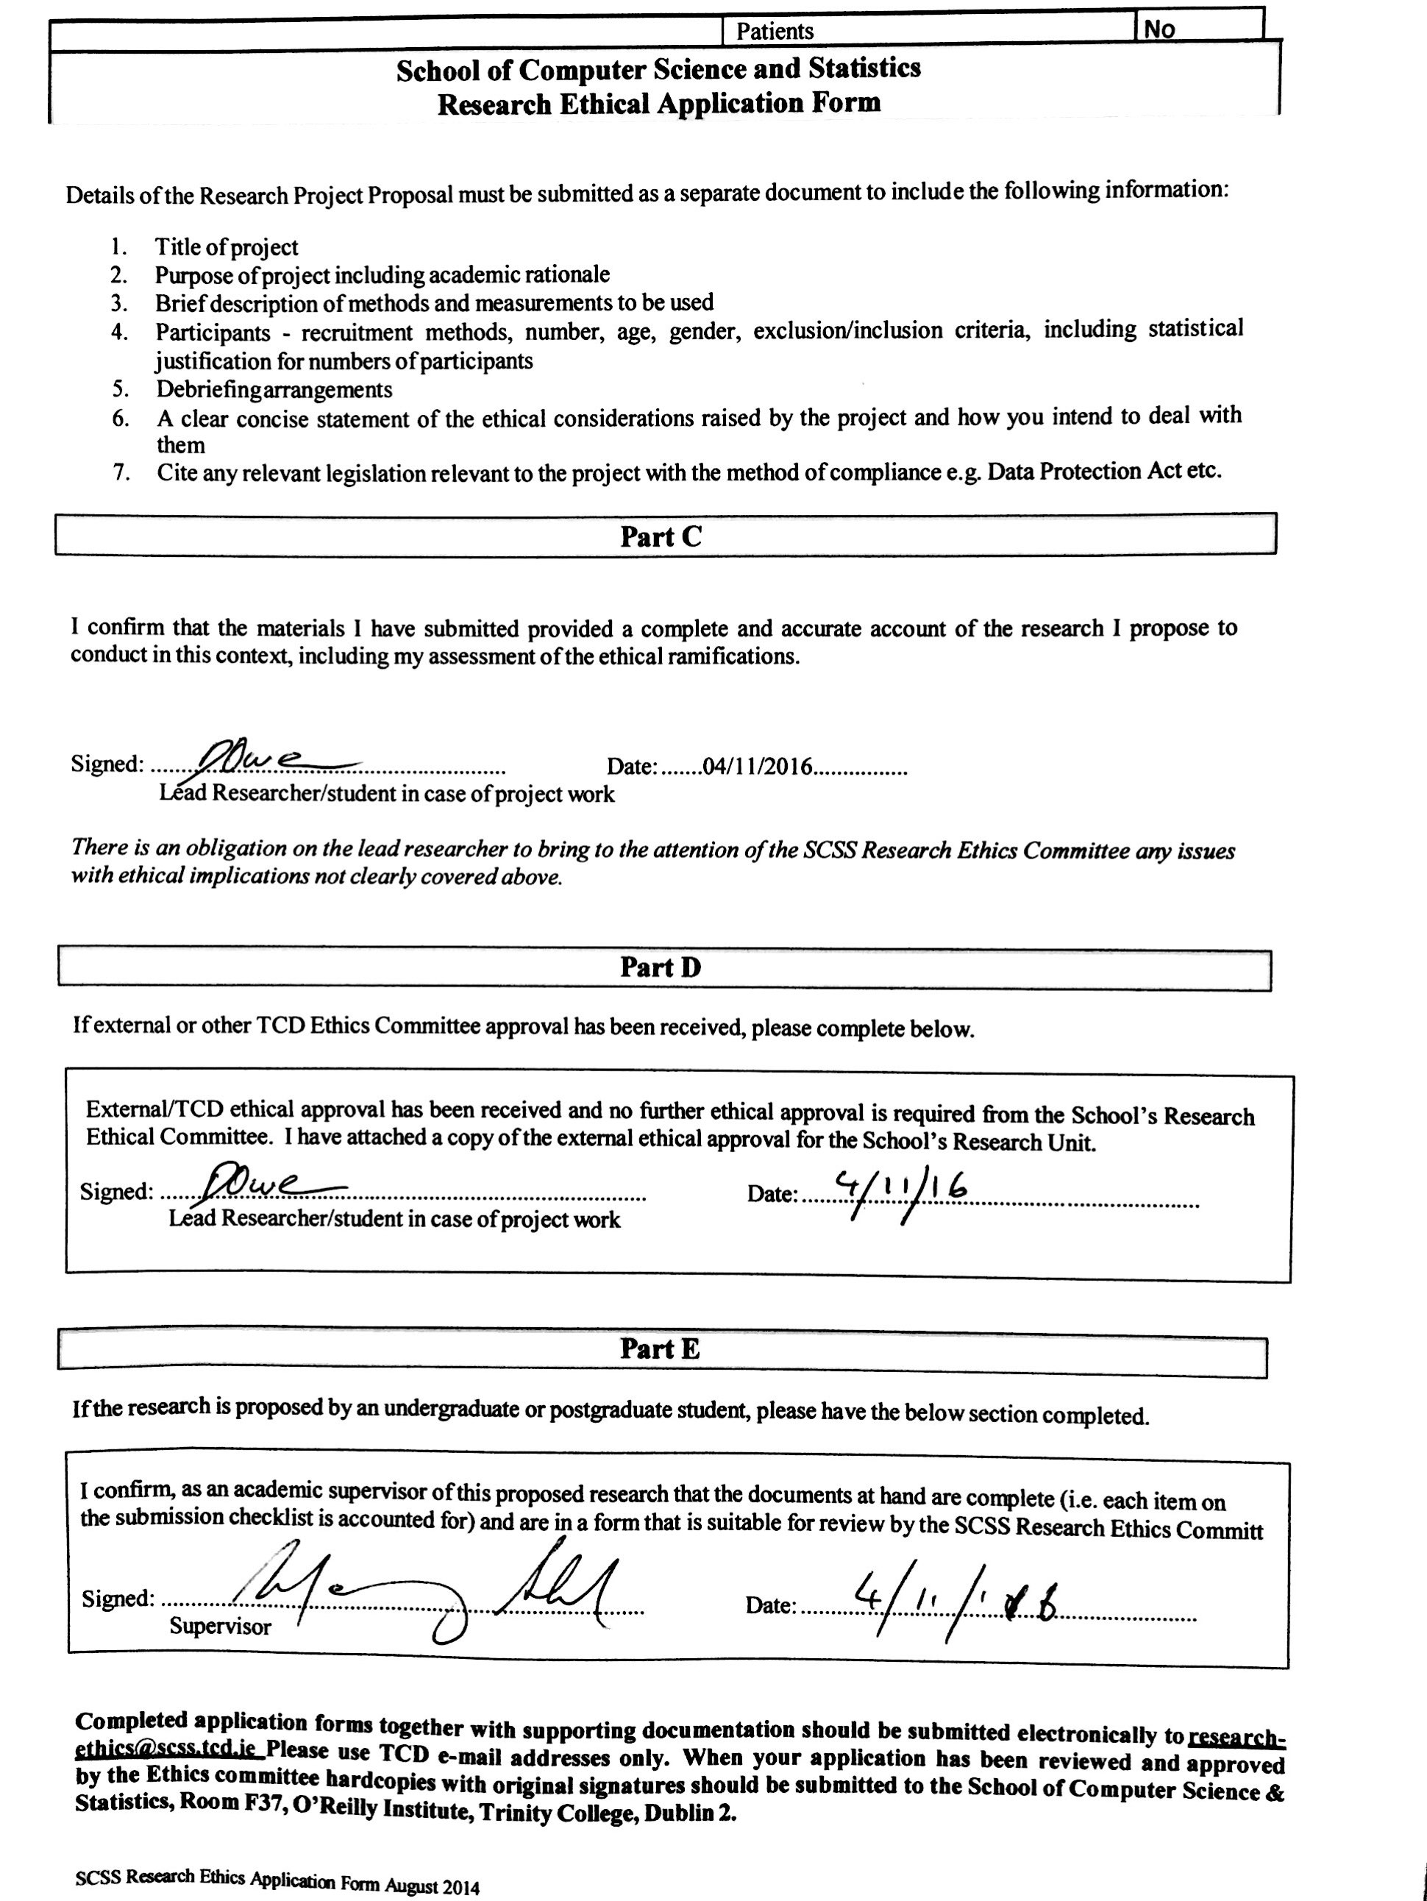

# TRINITY COLLEGE DUBLIN

## INFORMED CONSENT FORM

##### LEAD RESEARCHERS: Daniel Owen

**BACKGROUND OF RESEARCH:** Research for my final year project for the B.A Mod in Computer Science and Business, Trinity College.

**PROCEDURES OF THIS STUDY:** I will ask a number of questions to find out more about how concussions and other head injuries are reported in domestic rugby.

**PUBLICATION:** All of the research carried out will go towards my final year project report and may be published in scientific publications.

Individual results may be aggregated anonymously and research reported on aggregate results.

##### DECLARATION:

* I am 18 years or older and am competent to provide consent.
* I have read, or had read to me, a document providing information about this research and this consent form. I have had the opportunity to ask questions and all my questions have been answered to my satisfaction and understand the description of the research that is being provided to me.
* I agree that my data is used for scientific purposes and I have no objection that my data is published in scientific publications in a way that does not reveal my identity.
* I understand that if I make illicit activities known, these will be reported to appropriate authorities.
* I understand that I may stop electronic recordings at any time, and that I may at any time, even subsequent to my participation have such recordings destroyed (except in situations such as above).
* I understand that, subject to the constraints above, no recordings will be replayed in any public forum or made available to any audience other than the current researchers/research team.
* I freely and voluntarily agree to be part of this research study, though without prejudice to my legal and ethical rights.
* I understand that I may refuse to answer any question and that I may withdraw at any time without penalty.
* I understand that my participation is fully anonymous and that no personal details about me will be recorded.
* I have received a copy of this agreement.

##### PARTICIPANT’S NAME: PARTICIPANT’S SIGNATURE:

**Date:**

**Statement of investigator’s responsibility:** I have explained the nature and purpose of this research study, the procedures to be undertaken and any risks that may be involved. I have offered to answer any questions and fully answered such questions. I believe that the participant understands my explanation and has freely given informed consent.

##### RESEARCHERS CONTACT DETAILS: Daniel Owen

##### Email: [dowen@tcd.ie](mailto:dowen@tcd.ie)

##### Phone: 0873118524

**INVESTIGATOR’S SIGNATURE:**

**Date:**

# TRINITY COLLEGE DUBLIN

## INFORMATION SHEET FOR PROSPECTIVE PARTICIPANTS

#### Title: The Reporting of Head Trauma in Rugby

#### Researcher: Daniel Owen

#### Course: Computer Science and Business

#### I would like to invite you to take part in this research study. Before you decide you need to understand why the research is being undertaken and what your involvement will be. Please take your time to read the following document. If you have any questions don’t hesitate to ask.

* You were chosen as a participant in this research because you are a referee with the IRFU and/or a referee with a provincial board.
* The questions in this interview are relevant to the research carried out for my final year project on the reporting of head trauma in rugby.
* There only foreseen conflict of interest will be that I will be taking advantage of already established relationships to help further my research.
* You have the right to withdraw at any time during the study and to omit individual responses without penalty.
* The original interview will only take around 15 minutes but follow up questions may be necessary.
* There are no anticipated risks for you.
* You may benefit from the use of a database of reported head trauma to help prevent future head injuries during matches at which you officiate.
* After the interview I will debrief you to get some feedback on questions asked during the interview.
* Any personal information given in this interview may be anonymized to protect your identity.
* If any illicit activity is uncovered over the course of this interview, the interviewer will be obliged to contact the relevant authorities.
* The interview will be recorded in order to verify direct quotations and in order for it to be transcribed to a password protected device at a later date in time after the interview.
* No audio recordings will be made available to anyone other than the research/research team, nor will any such recordings be replayed in any public forum or presentation of the research.

Title: The Reporting of Head Trauma in Rugby

Purpose of project: For my final year project for the B.A Mod in Computer Science and Business, Trinity College

Description of measurements and methods used: The interview will be conducted to see how head trauma is reported after a match by referees.

Participants: Anyone over the age of 18 who is a registered referee with the IRFU or any of the provincial boards is welcome to participate in the study. Nobody is excluded based on race or gender. The study will be small in order to gain some insight into the reporting of head trauma and concussions in rugby. There is no statistical justification for the small number of participants needed.

Debriefing arrangements: Feedback will be given at the end of the interview and the participant will be thanked for helping with the research into the reporting of head trauma in rugby.

Ethical considerations:

* If during the interview any illegal or illicit activity is uncovered I will be obliged to report it to the relevant authorities.
* If any personal information is given over the course of the interview this information will be anonymised. Once the information is anonymised the participant will be unable to exclude themselves or any information from the study.
* I will be making an audio recording of the interview to transcribe after the interview. Both the device I make the audio recording on and the device I transcribe the interview to will both be password protected in order to protect the identity of the participant and the integrity of the data.
* The audio recording I make will only be made available to the research team and will not be made available on any public platform.
* Once the project has been completed, I will dispose of the recording by permanently deleting it and by shredding any hard files relating to it.
* The participant has the right for any information given by them to be protected under the Data Protection Acts 1988 and 2003.

**Interview Questions**

* How long have you been involved in rugby between playing and then refereeing?
* How long have you been involved in refereeing rugby?
* Are there certain courses that you have to do to become a qualified referee?
* When it comes to moving up the ranks, is that done through assessments of your skills by an assessor or do you have to complete more courses?
* What is the protocol when it comes to an injury of any kind on the pitch and more specifically a head injury?
* Is this then reported to a safety board or what is done?
* Are there any forms to be filled out?
* Are there any differences in this protocol at a club/schools/domestic level than at a professional level?
* Has there been a time where you’ve suspected that someone has received a head injury but a coach passed it off as a shoulder injury or a neck injury allowing the player to play on?
* What would be your stance if this happened?
* Would you be willing to fill out an online form to help referees in the future with players who may have suffered head injuries wishing to play before they have completed the gradual return to play (GRTP) protocol?
* Has the way that head injuries have been reported changed much over the years?